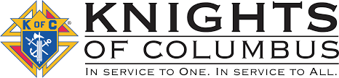

May 2026
Our next meeting will be at St. Edward’s, Elmdale on May 5th at 8pm (note time change). If anyone has questions or items for the agenda, please call Grand Knight Jeff Czech 630-2753.

Agenda Items:
-Council officer nominations
-summer parades

DAYS OF IMPORTANCE THIS MONTH…
5/10 – Mother’s Day
5/14 – The Ascension of the Lord
5/24 – Pentecost
5/25 – Memorial Day
5/31 – The Most Holy Trinity

That time of the year of our council’s officer’s nominations. Moreover, our financial secretary officer position is open, as Mike Nix is stepping down from the position at the end of June. If you would be interested in the position please contact Mike, Jeff or any other officer.
St. Gregory the Great
Council #12604

Trivia Question… What are the three prime devotions of Jesus Christ?

Escorts at St. Cloud VA. Please mark your calendars. We need to help out our Veteran’s for service and mass on May 31st.

Thank you to those that helped at St. Otto’s bingo. It was a wonderful time for the residents.

Thank you to all that returned their state KC raffle tickets. Great fundraiser for our council. Good luck to everyone...

Message: The nicer weather of year is beginning to show up outside and it’s nice to relax its comfort, yet do not relax too easily to forget to pray the rosary, chaplet or devotions for our church, priests, holy orders and conversion of hearts and minds. -Jeff

