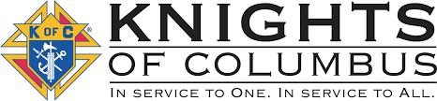

**October 2025**

**Our next meeting will be at St. Edward’s, Elmdale at 8:00pm on October 7. If anyone has questions or items for the agenda, please call Grand Knight Jeff Czech at 320-630-2753.**

**Agenda Items:**

**-Christmas party/potluck**

**-Mass intention for deceased Knights**

**-Other items…**

**DAYS OF IMPORTANCE THIS MONTH…**

10/1 – St. Therese of the Child Jesus

10/2 – Holy Guardian Angels

10/7 – Our Lady of the Rosary

10/15 – St. Teresa of Jesus, Virgin

**Ditch clean up did not occur due to shoulder road work and other circumstances. Keep in mind, will do in the spring.**

St. Gregory the Great

Council #12604

Trivia Question…What was our Blessed Mother’s main message in La Salette, France for two children and the world in 1846?

**VA escorts will be needed in November. A reminder will be in next newsletter also.**

**Thank you to all the officers of our council for the work you do; with continued help, fun and prayer for the community and our Catholic church.**

Message: Continue to pray for our Pope, Bishops, Priests, Holy Order Men and Women, families and our enemies. -Jeff

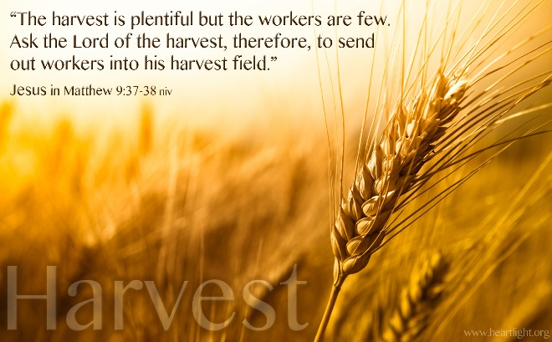

[This Photo](https://www.heartlight.org/articles/201710/20171010_1trains2.html) by Unknown Author is licensed under [CC BY-NC-ND](https://creativecommons.org/licenses/by-nc-nd/3.0/)