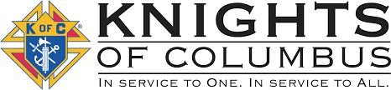

**August 2025**

**Our next meeting will be at St. Edward’s, Elmdale at 8:00pm on August 5. If anyone has questions or items for the agenda, please call Grand Knight Jeff Czech at 320-630-2753.**

**Agenda Items:**

**-Upsala parade**

**DAYS OF IMPORTANCE THIS MONTH…**

8/6 – The Transfiguration of the Lord

8/15 – Assumption of the Blessed Virgin Mary

8/22 – The Queenship of the Blessed Virgin Mary

**VA escorts in St. Cloud on August 31st. 7:35am arrival.**

**Thank you to all that helped with our KC float in the Bowlus parade!**

We will have installation of officers at the next meeting. All officers are asked to come to the meeting.

St. Gregory the Great

Council #12604

Trivia Question…What is the name of the blue color used in St. Edward’s church alter area?

August 9th Upsala Heritage Days parade. Meet at Gethsemane parking lot by 3/3:15. We need 4-6 riding on the float and 2-4 walking handing out rosary cards. Call John Kokett with questions 320-573-4239.

August 15th through 17th Family Outing held in Belle Prairie, north of Little Falls. The Knights of our Council are welcomed to be present at this event. If you would like to go for some of the time and help out, please be in contact with Kim Zimmerman 320-247-2293. A schedule for the event is enclosed.

Message: Please continue to pray for the conversion of hearts and minds of our Nation, increased virtues of Faith, Hope and Charity and for Pope Leo XIV, Bishops, Priests and Holy Orders. -Jeff