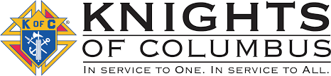

December 2025
Our next meeting will be at St. Edward’s, Elmdale at 7:00pm on December 9 (Note time change). If anyone has questions or items for the agenda, please call Grand Knight Jeff Czech at 320-630-2753.

Agenda Items:
-Free throw contest in January

DAYS OF IMPORTANCE THIS MONTH…
12/8 – Immaculate Conception of the Blessed Virgin Mary
12/12 – Our Lady of Guadalupe
12/25 – The Nativity of the Lord
12/28 – Holy Family of Jesus, Mary and Joseph

Dec. 14...Our K of C sponsored Christmas family potluck following the 10am mass in Upsala. All are welcome, mention to a friend. Bring your favorite dish to share. Gift treats for the kids will be handed out.

St. Gregory the Great
Council #12604

Trivia Question…Where was the first Thanksgiving mass celebrated and year?
Thank you to all that were escorts at St. Cloud VA recently and this entire year.

Decembers meeting we will be putting together treat bags for the kids to be handed out at our Christmas potluck. There will also be a presentation of the Family Outing video.

Message: The season of Advent has begun. The King of the universe came to us in the beginning as a baby in a manger. We are children, too. -Jeff

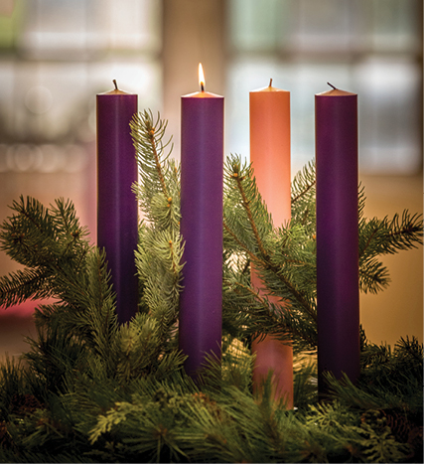
This Photo by Unknown Author is licensed under CC BY-NC-ND

