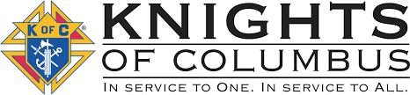

**September 2025**

**Our next meeting will be at St. Edward’s, Elmdale at 8:00pm on September 9. If anyone has questions or items for the agenda, please call Grand Knight Jeff Czech at 320-630-2753.**

**Agenda Items:**

**-Fall ditch clean up**

**-Family Potluck gathering**

**DAYS OF IMPORTANCE THIS MONTH…**

9/3 – Saint Gregory the Great, Pope and Doctor of the Church

9/8 – Nativity of the Blessed Virgin Mary

9/14 – The Exaltation of the Holy Cross

9/15 – Our Lady of Sorrows

9/29 – Saints Michael, Gabriel and Raphael, Archangels

**Thank you to those who helped with escorting at the St. Cloud VA.**

St. Gregory the Great

Council #12604

Trivia Question…Which saint found the true cross that Jesus was nailed to?

**Thank you for those attending the Belle Prairie Family Outing who helped out or participated.**

Our KC Council has been invited to join the Newman Center of Mankato for a Dinner/Program/Social which includes keynote speaker Bishop Robert Barron of Winona Diocese on October 5. Any interested council members can call Jeff for more information.

Message: Fall is around the corner. Be safe in your harvests and give thanks for the fruits you have received. Continue to pray for our Pope, clergy, Holy Orders and conversion of hearts and minds. -Jeff